[**https://github.com/gnawd/sit323-737-2023-t1-prac7p.git**](https://github.com/gnawd/sit323-737-2023-t1-prac7p.git)

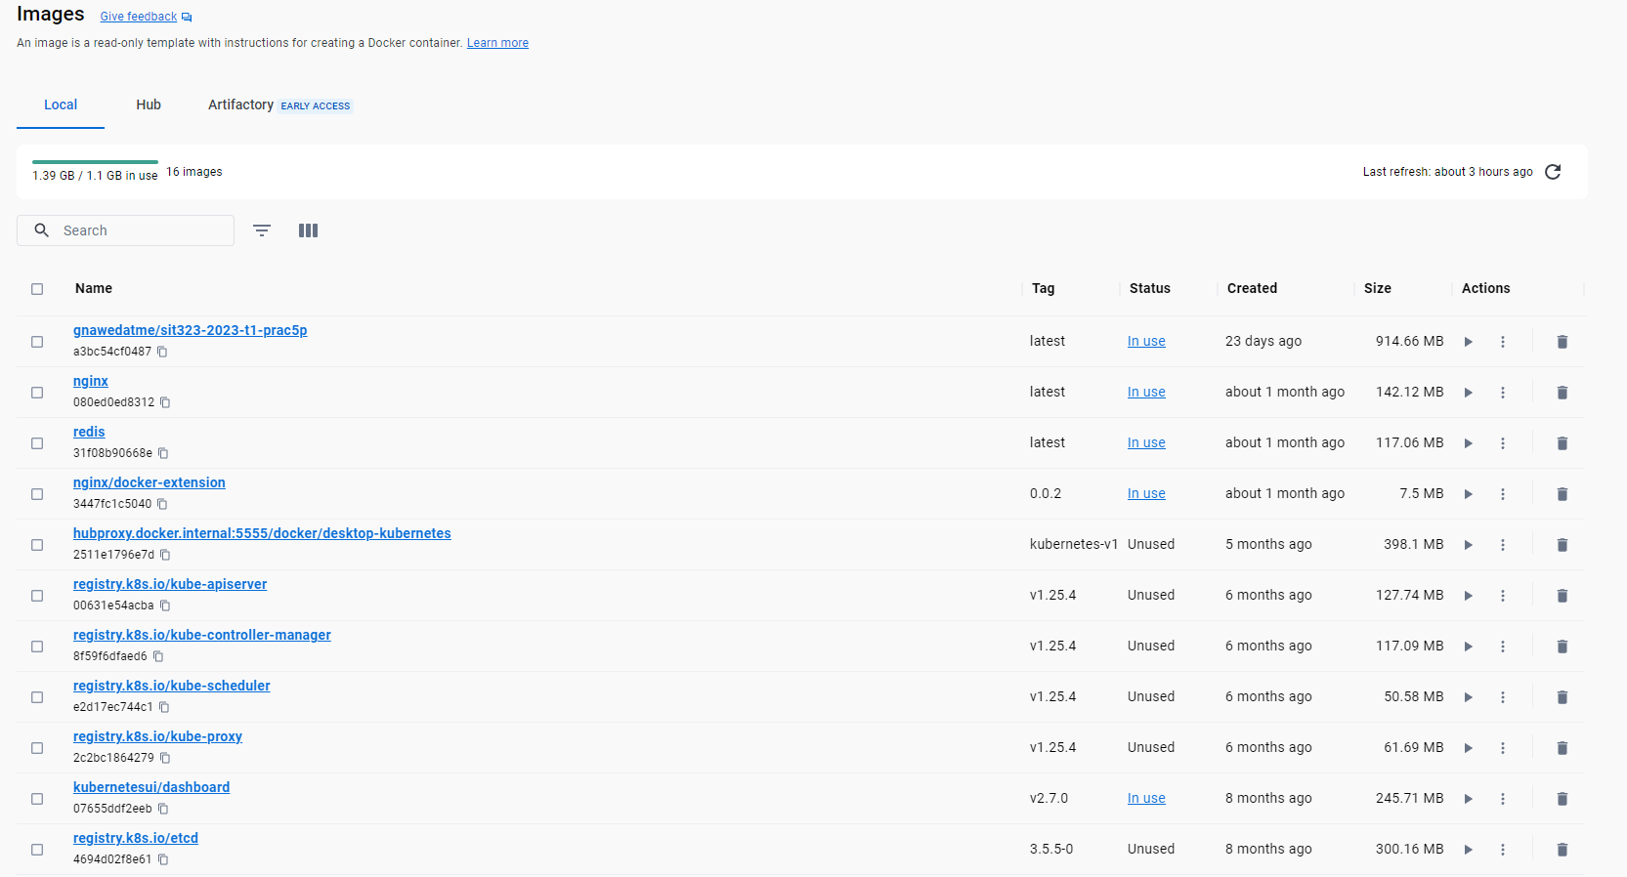

Docker-Desktop

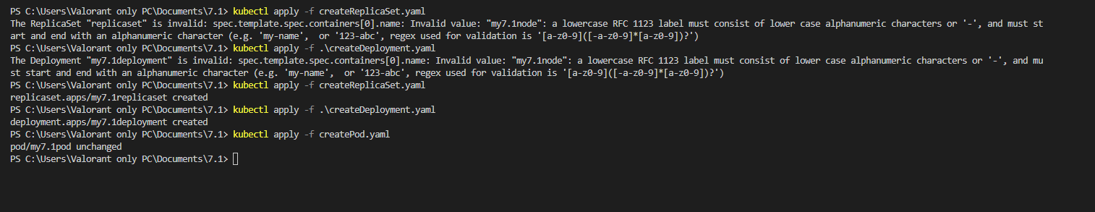

Terminal

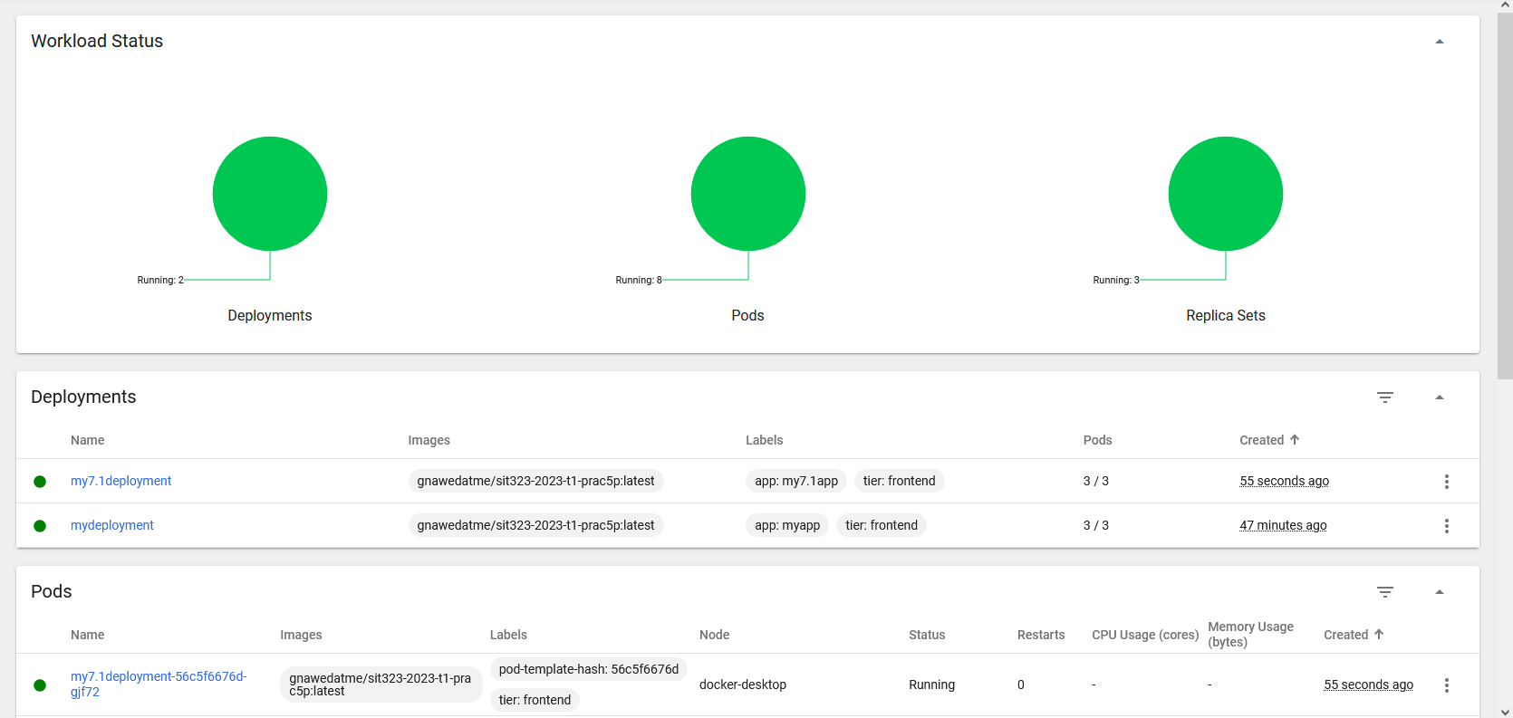

Dashboard

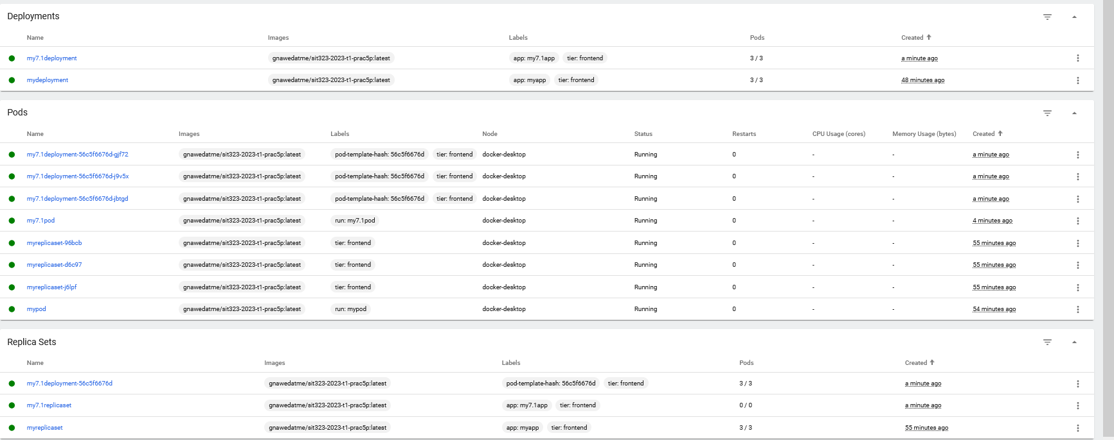

Development + Pods + Replica Sets

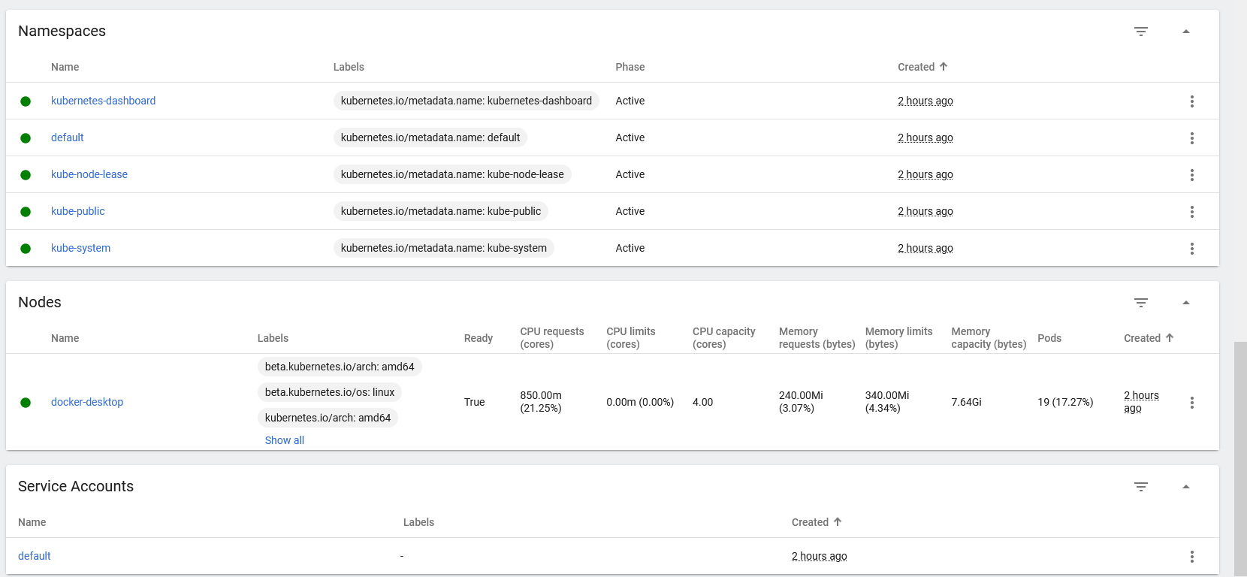

Namespaces + Nodes

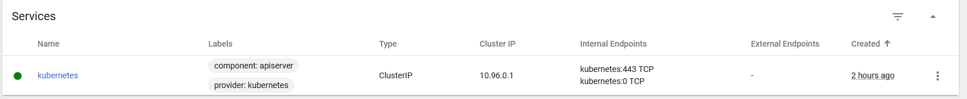

Services

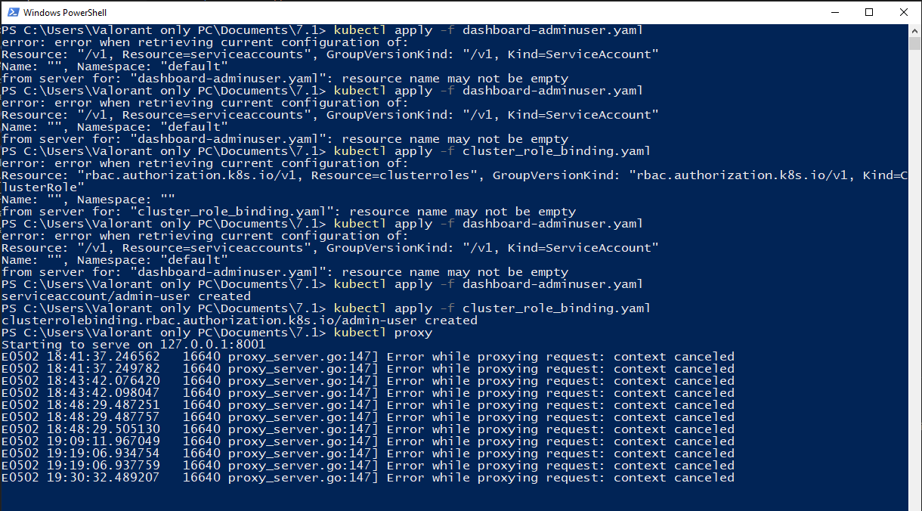

PowerShell interface